Muscle contraction relies on the Sliding Filament Theory, where thick (myosin) and thin (actin) filaments slide past one another to shorten the sarcomere. This cycle of activation, contraction, and relaxation is driven by nerve impulses and fueled by ATP.
1. Neuromuscular Activation
- Signal Transmission: A conscious or reflex signal travels down a motor neuron to the Neuromuscular Junction (NMJ).
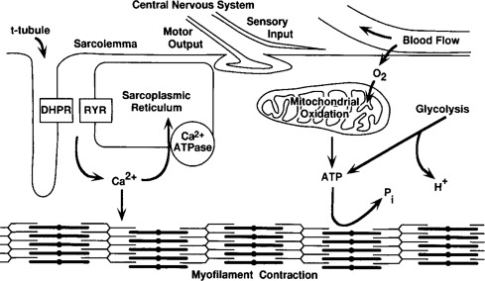
- Neurotransmitter Release: The motor neuron releases acetylcholine (ACh) into the synaptic cleft, which binds to receptors on the sarcolemma (muscle cell membrane).
- Action Potential: This binding triggers an electrical impulse that travels across the sarcolemma and deep into the muscle fiber via T-tubules

2. The Contraction Cycle
- Calcium Release: The impulse reaches the Sarcoplasmic Reticulum (SR), causing it to release stored \(Ca^{2+}\) ions into the cytoplasm.
- Exposing Binding Sites: Calcium ions bind to troponin on the actin filament, shifting tropomyosin and exposing the active binding sites for myosin.
- Cross-Bridge Formation: Energized myosin heads bind to the exposed actin sites, forming a cross-bridge.
- Power Stroke: Myosin heads pivot, pulling the actin filament toward the center of the sarcomere (M-line), shortening the muscle fiber. Energy for this movement comes from the release of ADP and Pi
3. Relaxation Phase
- Reuptake of Calcium: Once the nerve signal stops, \(Ca^{2+}\) is actively pumped back into the sarcoplasmic reticulum.
- Blocking the Site: Troponin and tropomyosin return to their resting positions, covering the actin binding sites and preventing further cross-bridge formation

4. Key Energy Requirements
- ATP Binding: A new ATP molecule must bind to the myosin head to detach it from actin.
- Resetting Myosin: Hydrolysis of ATP to ADP and Pi resets the myosin head into its "cocked" high-energy position, ready for the next contraction

